Section 4(ii) & (iii) | Team Structure, Experience and Qualification of the Team
1.0 | Architectural Designer



Company Profile

At Chung Wah Nan Architects Ltd, we are committed to delivering exceptional architectural services that reflect our innovative spirit and dedication to quality. Established in 1964, we have consistently shaped the built environment of Hong Kong through our diverse portfolio and expertise.

Our Journey

Founded by Mr. Chung Wah Nan, our firm began as a private practice and evolved into a partnership with Mr. Alan Fitch in 1970, known as Fitch & Chung. Following Mr. Fitch's retirement in 1995, we rebranded as Chung Wah Nan Architects Ltd, continuing our legacy of excellence and innovation.

Directors
Wilbert Ching 1977 - present, Partner in 1985
C.C. Tang 1977 - present, Partner in 1989
Doris Tang 1997 - 2004, 2019-present, Partner in 2019

Leadership
Wilbert Ching: Partner at Chung Wah Nan & Partners (1985-present)
C.C. Tang: Partner at Chung Wah Nan & Partners (1989-present)
Doris Tang: Partner (1997-2004, 2019-present)

Featured Projects

Our extensive portfolio includes

• The Peak Tower (1972):
An iconic space-age structure blending modernism with Chinese watchtower elements. Served as the upper terminus for the Peak Tram and became a symbol of Hong Kong's confidence. Demolished in 1993 for a larger replacement, but its design remains significant in Hong Kong's architectural history.
• Liaison Office of the Central People’s Government (interior fitting out) (2000)
• City University of Hong Kong (1983 - 1992)
• Lok Fu Complex (1989)
• Ma On Shan Waterfront Promenade (2010)
• Po Fook Hill Columbarium (1989)
• International Organization for Mediation (2025)

Our Expertise

We have successfully completed a diverse range of projects, including public and private residential developments, departmental quarters, universities and colleges, parks, gardens and promenades, as well as government buildings. The firm has experience with various sizes of projects, encompassing new builds, alterations and additions, renovations, and interior design. Additionally, the practice has been active in Design & Build since 1994, successfully managing sizable projects to ensure satisfaction for both clients and contractors while focusing on high-quality outcomes and balancing cost considerations.

Our Vision

At Chung Wah Nan Architects Ltd, we prioritize a hands-on approach to service, with direct involvement from our directors. This ensures timely recommendations and close supervision while effectively balancing design quality, cost, and time. Our proven track record reflects our commitment to high-quality architectural services.
Moreover, we are dedicated to passing on our rich culture of architectural service to the next generation. By mentoring aspiring architects and fostering a collaborative environment, we aim to fostering creativity, integrity, and community engagement, thereby ensuring that its legacy of architectural excellence continues to flourish.

  - Relevant Project Reference

1.2.1 Similar Projects

Project: | Junior Police Officers Married Quarters at Fan Garden
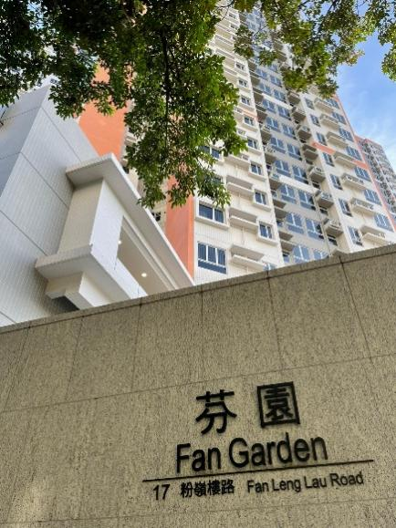
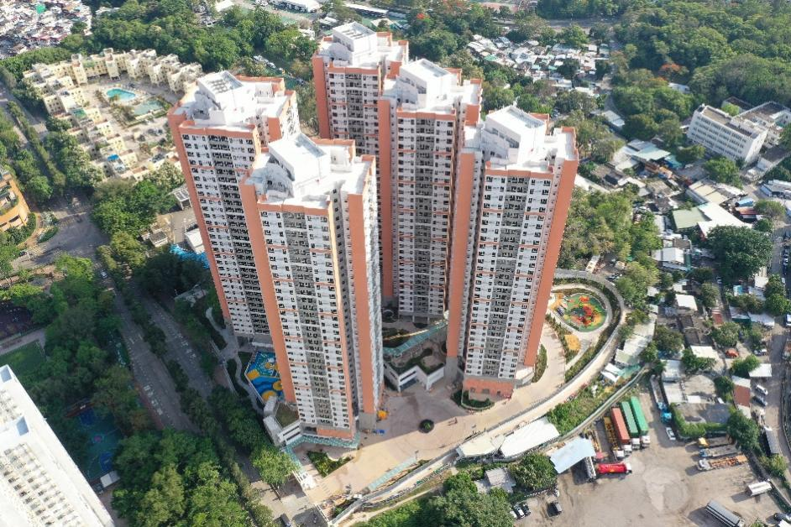

Please refer to Section 4(i)(b) Job Reference (1.0 Architectural Designer) – Project 1 for full project description.

Project Cost: | HK$2,720M
Completion: | 2021
Client: | Architectural Services Department

Project: | Greenhill Villa at 63 Siu Lek Yuen Road, Shatin, S.T.T.L. 577
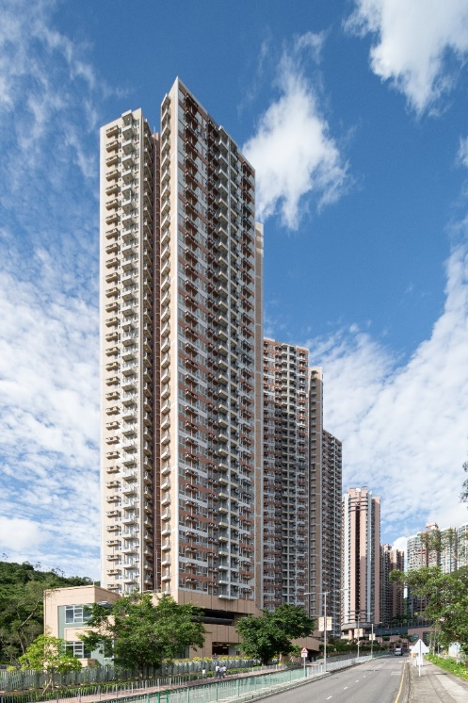
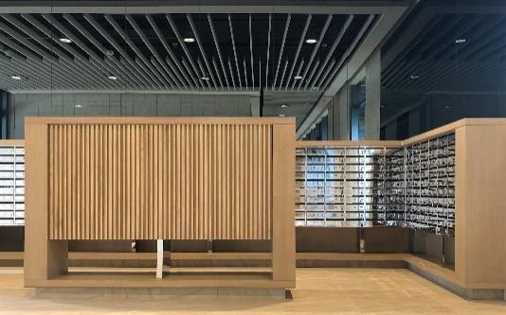

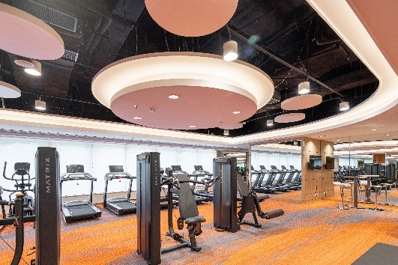

Please refer to Section 4(i)(b) Job Reference (1.0 Architectural Designer) – Project 2 for full project description.

Project Cost: | HK$1,600M
Completion: | 2021
Client: | Hong Kong Housing Society

Project: | Renovation Works for the HQ of an International Organization  (International Organization for Mediation) in Wan Chai Police Station (Grade 2 Historical Building)
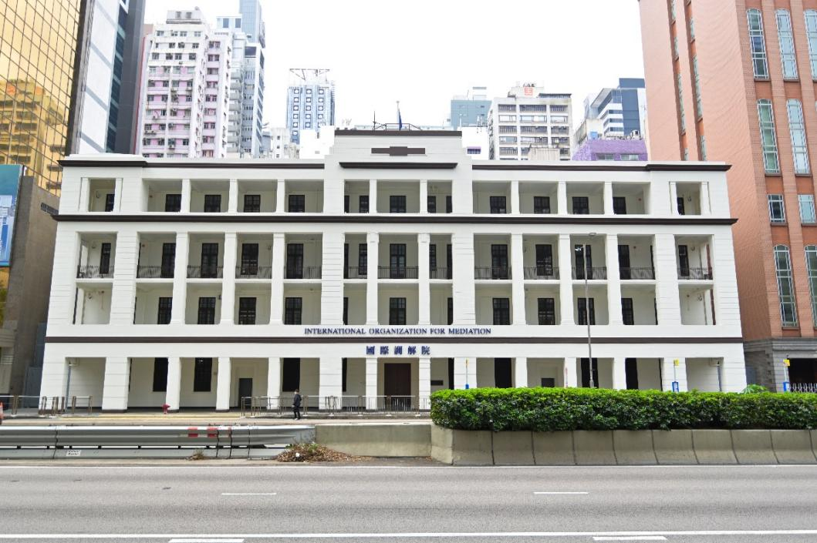

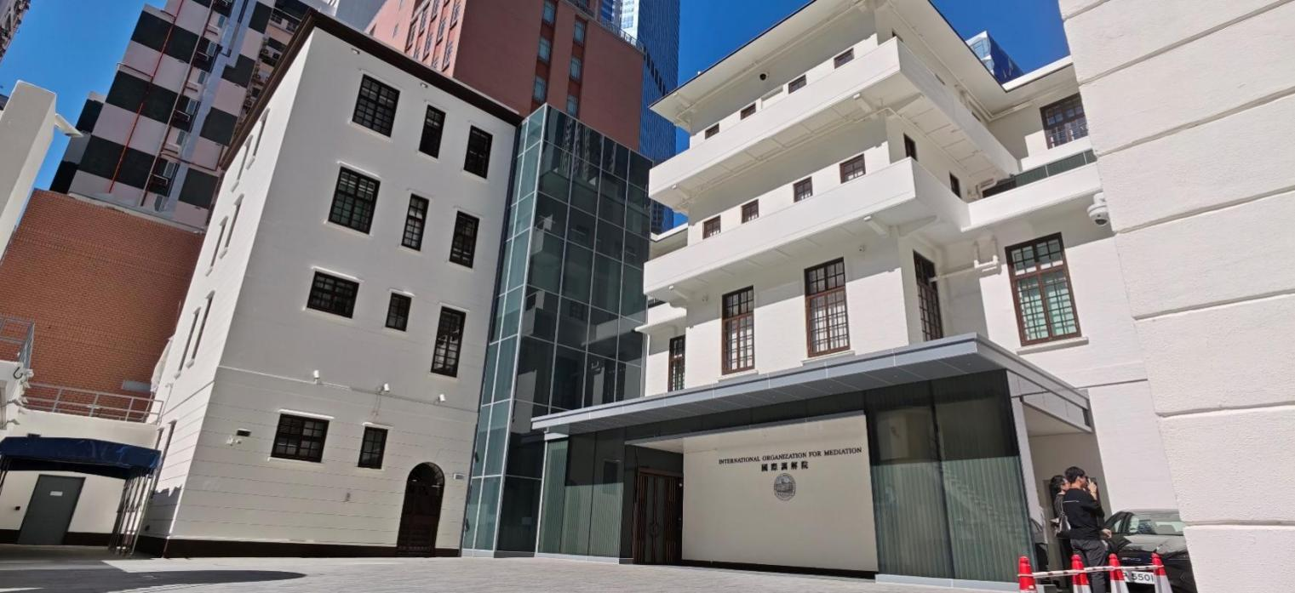

Please refer to Section 4(i)(b) Job Reference (1.0 Architectural Designer) – Project 3 for full project description.

Project Cost: | HK$375.9M
Completion: | 2025
Client: | Architectural Services Department

1.2.2 Universities Projects ,….

Project: | A22102 - Spatial Reorganization Works for College of Science  A22103 - Provision of Teaching and Research Laboratories for Interdisciplinary Collaboration
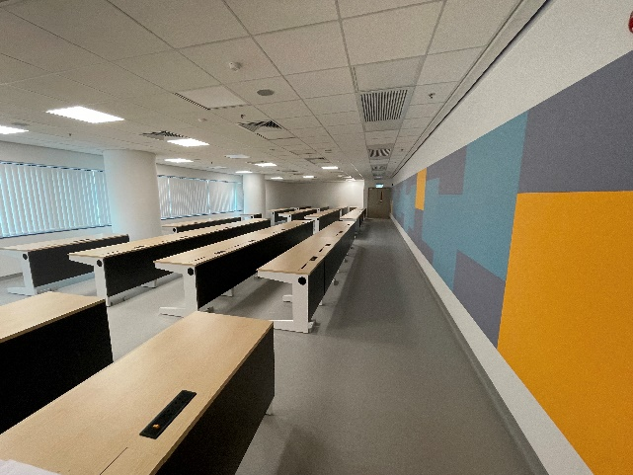
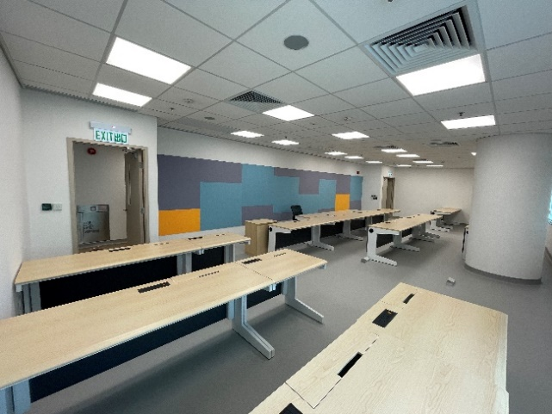

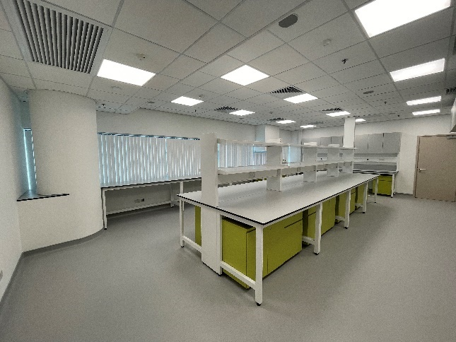

The project involves the re‑layout of existing rooms and provisions.

Project A22102 comprises comprehensive spatial reorganization works on the 5th floor for the Department of Physics and the Department of Mathematics, with the objective of maximizing spatial efficiency, upgrading departmental facilities, and enhancing the overall academic environment.

Project A22103 delivers teaching and research laboratories on the 7th floor. These advanced facilities are purpose‑designed to foster interdisciplinary collaboration and provide the highly specialized infrastructure required to support scientific research and cross‑departmental synergy.
Project Cost: | HK$60M
Completion: | 2023
Client: | City University

Project: | B1203, Provision of Dangerous Goods Stores on 5th Floor of Bank of China (Hong Kong) complex Delegation of Authority
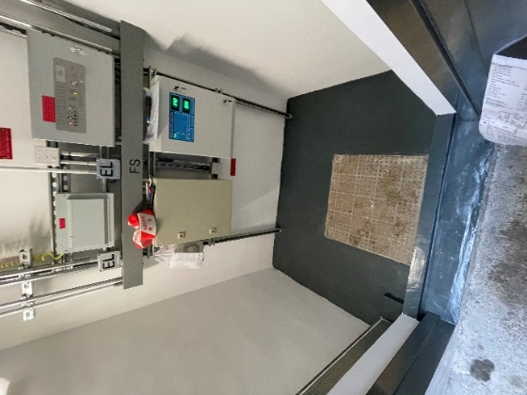
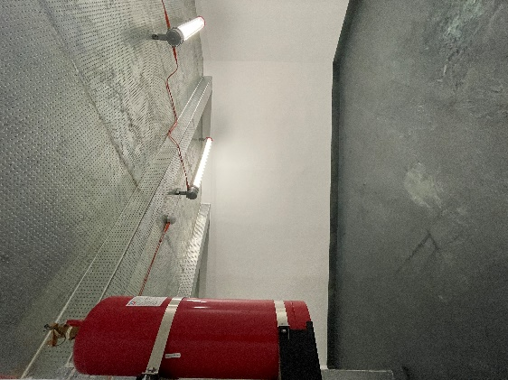

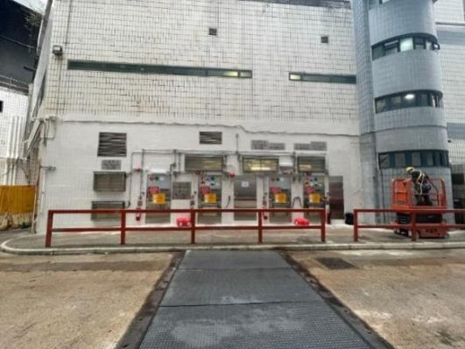

Please refer to Section 4(i)(b) Job Reference (1.0 Architectural Designer) – Project 5 for full project description.

Project Cost: | HK$7M
Completion: | 2023
Client: | City University

  - Duties and Responsibility

The Duties and responsibility of the core personnel are as follow:

Name (Position) | Duties and Responsibility
Ching Tak Keung, Wilbert  Principal Director | Mr. Wilbert Ching will be the Principal Director for the project. He will oversee the design and management for the project and be responsible for the following:  - Overseeing the project by leading the overall direction, guiding multidisciplinary teams, and ensuring all milestones and deliverables are met to the highest standard.  - Attend design meetings, progress meetings, project control group meetings, liaison meetings with users and relevant statutory bodies and government departments, when necessary
Tang Che Ching  Design Director | Mr. C. C Tang will lead the team of architects and designers and be responsible for the following:  - Undertake architectural design  - Direct overall design with the design team and construction team to ensure that the overall architectural design is well-integrated and fully complied with eh Client’s Requirements and Statutory Requirements.  - Attend design coordination meetings, progress meetings, project control group meetings, mock-up inspections, liaison meetings with users.  - Carry out site inspections and supervision, when necessary
Tang Yuet Ching, Doris  Project Director  (Key Person) | Ms. Doris Tang will be the Architect-in-charge for the project, and will act as Authorized Person (Architect) for the project. He will oversee the design and management for the project He will be responsible for the following:  - Direct design team to undertake architectural design  - Take the Leading role in overall design coordination and integration of all design output by other designers  - Perform the statutory duties of Authorized Person  - Attend design coordination meetings, progress meetings, project control group meetings, liaison meetings with users and relevant statutory bodies and government departments  - Project coordination  - Organise timely project submissions  - Carry out site inspection and supervision
Yeo Wee Wah  Chief Architect | Mr Yeo will be the Chief Architect and provide full support to the Directors. He will:  - Assist Project Directors to manage and allocate resources to achieve timely completion of works tasks at milestone dates and overall completion of the project  - Assist Project Directors to give directions and guidance on design, project administration and contract management  - Report directly to the Directors  - Head and closely work with a team of designer, architect and architectural assistants to carry out design development, detailed design, project submission preparation the day-to-day task of project administration and contract management  - Attend all design meetings, site meetings  - Co-ordinate with other disciplines on technical matters and drawings  - Carry out periodic site inspections to ensure quality, and safety  - Vet and endorse all design, drawing production, co-ordination with other designers, contractor and sub-contractor


  - Organization Chart

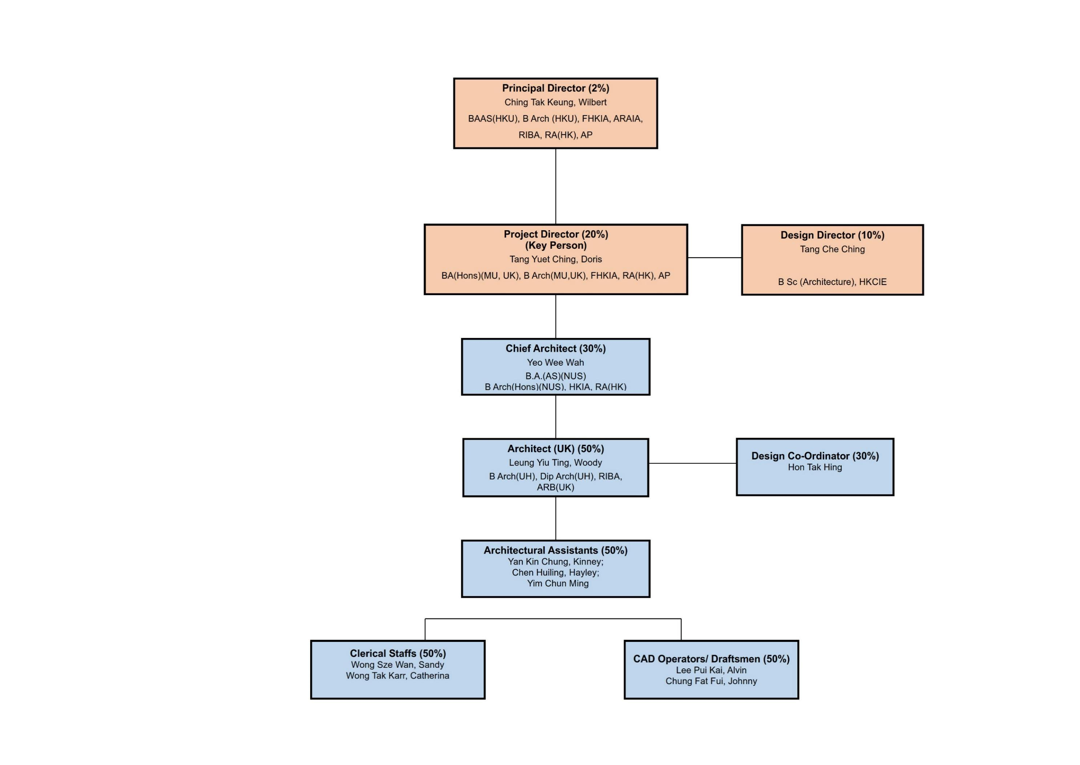

  - CV of Architectural Designer
THE KEY PERSON FOR THE DESIGN MANAGEMENT TEAM
Staff  assigned to this contract  (name) | Key person | Part 1 – Qualification |  | Part 2 – Experience
 |  | Professional Qualifications | Date of award (mm/yy) | Year of Post Qualification Experience in the capacity of the Position in this proposal | Employment Period
 |  |  |  |  | Company | Post | From  (dd/mm/yy) | To  (dd/mm/yy)
Architectural Consultant
Ching Tak Keung, Wilbert | Principal Director | Registered Architect (ARB) | 1991 | 35 | Chung Wah Nan Architects Limited | Director | 1996 | Present
 |  | Authorized Person (Architect) | 1986 |  | Chung Wah Nan & Partners | Partner | 1984 | 1995
 |  | Corporate Member, Royal Institute of British Architect | 1982 |  | Alan Fitch & W.N. Chung Architects | Architect / Associate | 1981 | 1984
 |  | Associate Member, Royal Australian Institute of Architects | 1981 |  | Alan Fitch & W.N. Chung Architects | Architectural Assistant | 1977 | 1981
 |  | Fellow, Hong Kong Institute of Architects | 2000
 |  | Member, Hong Kong Institute of Architects | 1981
Tang Che Ching | Design Director | Member, Hong Kong Chinese Institute of Engineers | 1982 | 44 | Chung Wah Nan Architects Limited | Director | 1996 | Present
 |  |  |  |  | Chung Wah Nan & Partners | Partner | 1989 | 1996
 |  |  |  |  |  | Associate | 1985 | 1989
 |  |  |  |  | Alan Fitch & W.N. Chung Architects | Architecture Assistant | 1977 | 1985
Tang Yuet Ching, Doris | Project Director  (Key Person) | Registered Architect (ARB) | 2001 | 25 years’ post-professional qualification experience  (i.e. Registered Architect) | Chung Wah Nan Architects Limited | Director | 2019 | Present
 |  | Authorized Person (Architects) | 2002 | 24 | Chung Wah Nan Architects Limited | Associate Director | 2018 | 2019
 |  | Fellow, Hong Kong Institute of Architects | 2021 |  | Percy Thomas Partnership (HK) Ltd | Director | 2014 | 2017
 |  | Hong Kong Institute of Architects | 2001 |  | Lotus Architects Ltd. | Senior Architect and Authorized Person | 2012 | 2013
 |  |  |  |  | Leigh & Orange Ltd. | Senior Resident Architect | 2010 | 2012
Yeo Wee Wah | Chief Architect | Registered Architect (ARB) | 2002 | 24 | Chung Wah Nan Architects Limited | Chief Architect | 2022 | Present
 |  |  |  |  | Hutchison Property Group Limited | Senior Project Manager | 2009 | 2019
 |  |  |  |  | P&T Architects Limited, Singapore | Project Architect | 2004 | 2006
 |  |  |  |  | Chung Wah Nan Architects Limited | Senior Architect | 2006 | 2008
 |  |  |  |  | Chung Wah Nan Architects Limited | Architect | 2002 | 2004

KEY PERSONS FOR THE Architectural CONSULTANT
Name of the key person: Ching Tak Keung, Wilbert
Current position: Principal Director

Registered Architect in Hong Kong under the Architects Registration Ordinance since 1991
Authorised Person (List of Architects) in Hong Kong as defined under the Buildings Ordinance since 1986
32 years’ post-professional qualification experience (Registered Architect) in design, supervision and coordination of construction projects

#Remark: (1) Similar Nature and Scope; (2) Universities, (3) Conversion, Design and Execution and completion of works at Residential Building, Hotel, Hostel; (4) Property Management at Residential building, Hotel Hostel; (5) other relevant experience
EXPERIENCE IN THE DESIGN, SUPERVISION AND COORDINATION OF CONSTRUCTION PROJECTS
COMPANY NAME | EMPLOYMENT PERIOD |  | POST | DUTIES | PROJECT TITLES | VALUE OF PROJECT ($M)  (at time of construction) | Details of experience in project (#Remark)
 | FROM  (dd/mm/yy) | TO  (dd/mm/yy
Chung Wah Nan Architects Limited | 1996 | Present | Director | 35 years’ post-professional qualification experience (i.e. Registered Architect) in design, supervision and coordination of construction projects  - Perform Authorized Person duties for the company projects since 1986  - Overall oversee the design and management of projects  - Manage and allocate resources to achieve timely completion of work tasks at milestone dates and over completion of projects  - Endorse schemes at various stages and provide guidance / judgement on design and policy matters  - Encompass financial and contractual discussion with the Clients’ Representatives, consultants and Sub-consultants  - Give directions and guidance on design, project administration and contract management  - Attend design meetings, progress meetings and site meetings  - Set up and monitor quality standards and project programme  - Quality assurance | Renovation Works for the HQ of an International Organization (International Organization for Mediation)
 |  |  |  |  | Design and Construction of West Police Married Quarters |  | (1), (2)
 |  |  |  |  | Design and Construction of Junior Police Married Quarters at Fan Garden, Fanling |  | (3)
 |  |  |  |  | Design and Construction of 144 Rank and File and Quarters for Immigration Department at Wo Yip Hop Road, Kwai Chung
 |  |  |  |  | Design and Construction of 584 Departmental Quarters at Hong Ning Road, Kwun Tong
Chung Wah Nan & Partners | 1984 | 1996 | Partner |  | Design and Construction of 3 District Open Space at Fan Ling, Tung Chung and Tsuen Wan
Alan Fitch & W.N. Chung Architects | 1981 | 1984 | Architect Associate |  | UC Market / Library Complex in Ngau Tau Kok Estate for Hong Kong Housing Authority
 | 1977 | 1981 | Architectural Assistant |  | Lockhart Road Market / Indoor Game Hall / Library / Office Complex in Wanchai for ArchSD
 |  |  |  |  | School Improvement Programme, Final Phase (Package 7) for ArchSD
Chung Wah Nan Architects Limited | 1996 | Present | Director |  | - School Improvement Programme for S.K.H. Wei Lun Primary School in Discovery Bay, Lantau
Chung Wah Nan & Partners | 1984 | 1996 | Partner |  | - TWGHs Kwok Yat Wai Prevocational School at Area 2, Tin Shui Wai, Yuen Long for Tung Wah Group of Hospitals
Alan Fitch & W.N. Chung Architects | 1981 | 1984 | Architect Associate |  | - Full Win Commercial Centre 569-573A Nathan Road, Kowloon for Fervent Estate Limited
 | 1977 | 1981 | Architectural Assistant |  | - Office and Commercial Development at 83-91 Nam On Street, Shaukiwan for Alfa Million Development Ltd.
 |  |  |  |  | - Bo Shek Mansion, 328 Sha Tsui Road, Tsuen Wan for Hong Kong Housing Society
 |  |  |  |  | - The Ellipsis, 5-7 Blue Pool Road, Happy Valley for Dorfit Properties Limited
 |  |  |  |  | - Subsidized Sale Project at Shatin Area 36C for Hong Kong Housing Society
 |  |  |  |  | - Subsidized Sale Project at 18 Tsing Luk Street, Tsing Yi for Hong Kong Housing Society
 |  |  |  |  | - Departmental Quarters for Immigration Department at 20 Heng Lam Street for ArchSD
 |  |  |  |  | - Rehabilitation of Moon Lok Dai Ha, Tsuen Wan for Hong Kong Housing Society
 |  |  |  |  | - Rehabilitation of Lai Tak Tsuen, Tai Hang for Hong Kong Housing Society
 |  |  |  |  | - Sunshine Grove, Sandwich Class Housing Development at Tai Yi Street, Shatin, STTL 430 for Hong Kong Housing Society
 |  |  |  |  | - Dragon Centre at 23 Wun Sha Street, Causeway Bay for Hong Kong Housing Society
 |  |  |  |  | - Public Housing for Small Household Infill Site Development at Lai Yiu Estate for Hong Kong Housing Authority
 |  |  |  |  | - Swimming Pool Complex in Ma On Shan for ArchSD
Chung Wah Nan Architects Limited | 1996 | Present | Director | 35 years’ post-professional qualification experience (i.e. Registered Architect) in design, supervision and coordination of construction projects | - Swimming Pool Complex (Phase 2) in Shatin for ArchSD
Chung Wah Nan & Partners | 1984 | 1996 | Partner |  | - Jordan Valley Playground Phase 2 Stage 1 for ArchSD
Alan Fitch & W.N. Chung Architects | 1981 | 1984 | Architect Associate |  | - Hong Ning Road Park Phase 2 for ArchSD
 | 1977 | 1981 | Architectural Assistant |  | - Sheung Lok Street Rest Garden (Site A) for ArchSD
 |  |  |  |  | - Open Space at Braemar Hill Road for ArchSD
 |  |  |  |  | - Junction Road Playground for Hong Kong Housing Authority
 |  |  |  |  | - District Open Space in Area 3 & 8, Tsing Yi for ArchSD
 |  |  |  |  | - District Open Space in Area 18, Tuen Mun for ArchSD
 |  |  |  |  | - Local Open Space in Area 15, Tin Shui Wai for ArchSD
 |  |  |  |  | - Ma On Shan Waterfront Promenade for ArchSD
 |  |  |  |  | - 3 Open Spaces in Area 28, Fanling/Sheung Shui, in Sham Tseng, Area 50, Tsuen Wan, in Shek Yam Estate (Phases I and IV), Kwai Chung for ArchSD
 |  |  |  |  | - Ancestral Worship Halls in Shatin for Up-Grade Development Ltd.
 |  |  |  |  | - Columbarium in Pun Chun Yuen, Tai Po for Cavanah Company Limited
 |  |  |  |  | - 5 pedestrian footbridges over Junction Road, Wang Tau Hom East Road and Wang Tau Hom South Road, Lok Fu for Hong Kong Housing Authority
 |  |  |  |  | - A pedestrian footbridge over Kwu Hang Road, Tsuen Wan for Hong Kong Housing Society

NAME | PROJECT TITLES | Past Performance Record
Ching Tak Keung, Wilbert | Renovation Works for the HQ of an International Organization  (International Organization for Mediation) | QBA award 2026 Commendation Merit Award
 | Subsidized Sale Project at 18 Tsing Luk Street, Tsing Yi for Hong Kong Housing Society
 | Ma On Shan Waterfront Promenade for ArchSD | 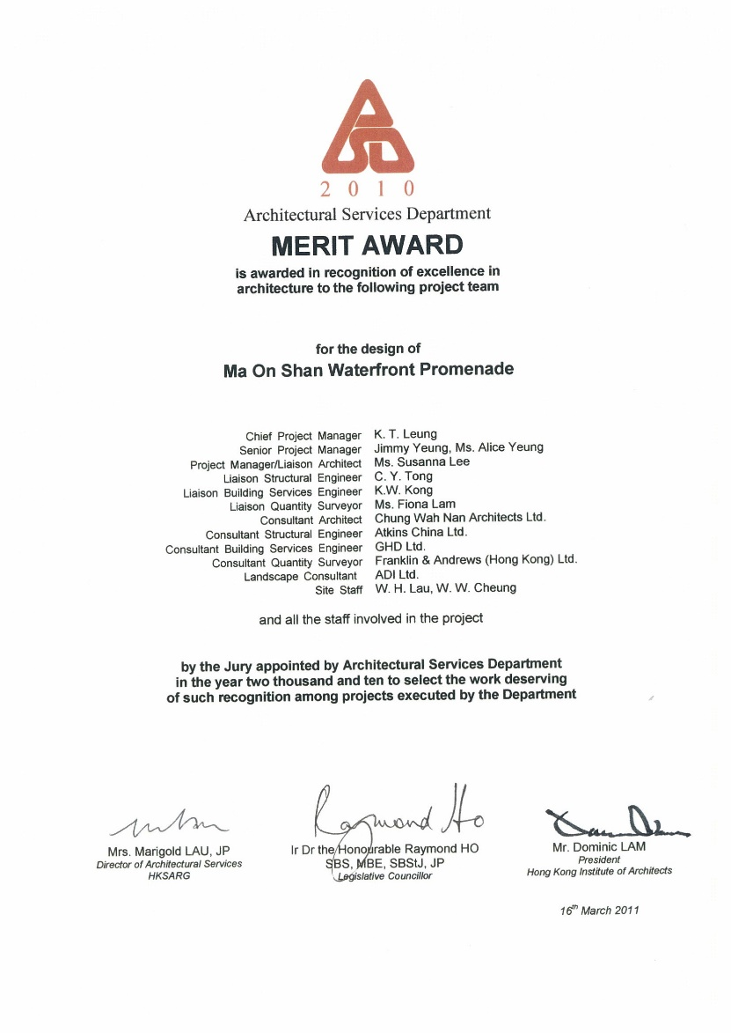
 | Rehabilitation of Moon Lok Dai Ha, Tsuen Wan for Hong Kong Housing Society | 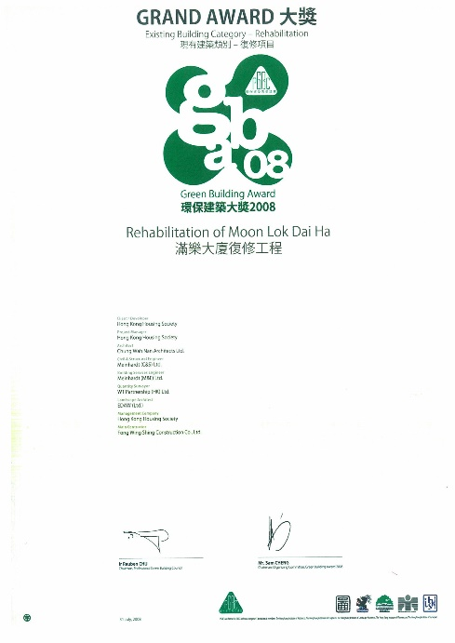
 | District Open Space in Area 3 & 8, Tsing Yi for ArchSD | 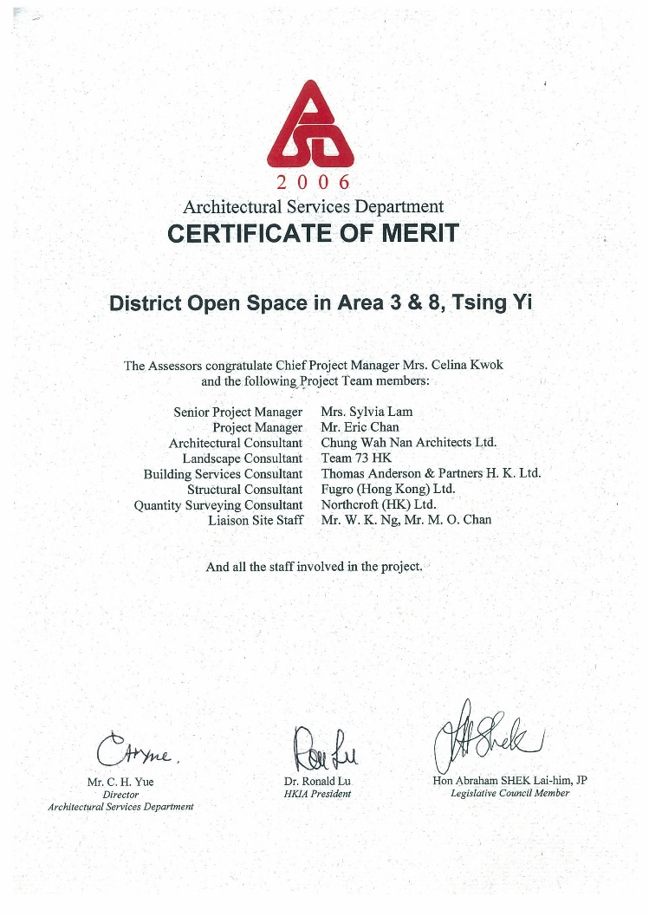

Name of the key person: Tang Che Ching
Current position: Director
#Remark: (1) Similar Nature and Scope; (2) Universities, (3) Conversion, Design and Execution and completion of works at Residential Building, Hotel, Hostel; (4) Property Management at Residential building, Hotel Hostel; (5) other relevant experience

EXPERIENCE IN THE DESIGN, SUPERVISION AND COORDINATION OF CONSTRUCTION PROJECTS
COMPANY NAME | EMPLOYMENT PERIOD |  | POST | DUTIES | PROJECT TITLES | VALUE OF PROJECT ($M)  (at time of construction) | Details of experience in project (#Remark)
 | FROM  (dd/mm/yy) | TO  (dd/mm/yy
Chung Wah Nan Architects Limited | 1996 | Present | Director |  | - Renovation Works for the HQ of an International Organization (International Organization for Mediation)
 |  |  |  |  | - 2019 Beijing International Horticultural Expo |  | 1
 |  |  |  |  | - 2011 Xi’an International Horticultural Exposition
 |  |  |  |  | - Subsidized Sale Project at 18 Tsing Luk Street, Tsing Yi for Hong Kong Housing Society
 |  |  |  |  | - Ma On Shan Waterfront Promenade for ArchSD
 |  |  |  |  | - Rehabilitation of Moon Lok Dai Ha, Tsuen Wan for Hong Kong Housing Society
 |  |  |  |  | - District Open Space in Area 3 & 8, Tsing Yi for ArchSD
Chung Wah Nan & Partners | 1989 | 1996 | Partner |  | - Contract for 144 Rank and File Quarters for Immigration Department at Wo Yi Hop Road, Kwai Chung for ArchSD
Alan Fitch & W.N. Chung Architects | 1985 | 1989 | Associate |  | - Contract for Senior Staff Quarters at Nam Shan Chuen Road, Kowloon for City Unversity of Hong Kong |  | 1
 | 1977 | 1985 | Architectural Assistant |  | - Main Campus Development Phases 1 & 2 in Yau Yat Chuen for City University of Hong Kong (worked in association with Percy Thomas Partnership) |  | 3
 |  |  |  |  | - TWGHs Kwok Yat Wai Prevocational School at Area 2, Tin Shui Wai, Yuen Long for Tung Wah Group of Hospitals
 |  |  |  |  | - Development of Caritas Bianchi College of Careers at Tseung Kwan O for Caritas Hong Kong
 |  |  |  |  | - Tong Tai Plaza, the Finance Street of Beijing, PRC for Beijing Tong Tai Real Estate Corporation Ltd.
 |  |  |  |  | - Kowloon Sub-Office at York Road for the Liaison Office of the Central People’s Government in the HKSAR
 |  |  |  |  | - Tregunter at Mid-Level for Hong Kong Land
 |  |  |  |  | - Nerine Cove in Tuen Mun, TMTL407 (a large scale residential development) for Macful Ltd.
 |  |  |  |  | - Sky Garden at 217-223, Prince Edward Road for Casania Investments Inc.
 |  |  |  |  | - Façade Consultant for La Cite’ at Macau
Chung Wah Nan Architects Limited | 1996 | Present | Director |  | - Development at No.1 Oxford Road, Kowloon Tong for Entrepot Ltd.
Chung Wah Nan & Partners | 1989 | 1996 | Partner |  | - Development at NKIL 6500, No.21-25 Grampian Road, Kowloon Tong, Kowloon for China Overseas (Holdings)
Alan Fitch & W.N. Chung Architects | 1985 | 1989 | Associate |  | - Development at RBL 1139, No.2 Cape Drive, Chung Hum Kok for Maxjet Co. Ltd.
 | 1977 | 1985 | Architectural Assistant |  | - Departmental Quarters for Immigration Department at 20 Heng Lam Street for ArchSD
 |  |  |  |  | - Development at Lot 19 (A1/M), Macau for China Overseas Finance (Cayman) III Ltd.
 |  |  |  |  | - Junction Road Playground for Hong Kong Housing Authority
 |  |  |  |  | - Harbour Road Park for ArchSD
 |  |  |  |  | - Admiralty overhead walkway and transport interchange for ArchSD / MTRC
 |  |  |  |  | - Cotton Tree Drive Cable-stay Pedestrian Footbridge for ArchSD / MTRC
 |  |  |  |  | - Soothsayers’ Stalls Redevelopment at Sik Sik Yuen, Wong Tai Sin Temple for Tung Wah Group of Hospitals
 |  |  |  |  | - Kung Sor Extension, Man Mo Temple for Tung Wah Group of Hospitals

NAME | PROJECT TITLES | Past Performance Record
Tang Che Ching | Renovation Works for the HQ of an International Organization  (International Organization for Mediation) | QBA award 2026 Commendation Merit Award
 | Subsidized Sale Project at 18 Tsing Luk Street, Tsing Yi for Hong Kong Housing Society
 | Ma On Shan Waterfront Promenade for ArchSD | 
 | Rehabilitation of Moon Lok Dai Ha, Tsuen Wan for Hong Kong Housing Society | 
 | District Open Space in Area 3 & 8, Tsing Yi for ArchSD | 

Name of the key person: Doris Tang
Current position: Director
#Remark: (1) Similar Nature and Scope; (2) Universities, (3) Conversion, Design and Execution and completion of works at Residential Building, Hotel, Hostel; (4) Property Management at Residential building, Hotel Hostel; (5) other relevant experience

EXPERIENCE IN THE DESIGN, SUPERVISION AND COORDINATION OF CONSTRUCTION PROJECTS
COMPANY NAME | EMPLOYMENT PERIOD |  | POST | DUTIES | PROJECT TITLES | VALUE OF PROJECT  ($M)  (at time of construction) | Details of experience in project (#Remark)
 | FROM  dd/mm/yy | TO  dd/mm/yy
Chung Wah Nan Architects Ltd. | 1997 | present | Director  (2019 – Present)  Associate Director  (2018)  Architect  (2001 – 2004)  Architectural Assistant  (1997 – 2001) | She is/was responsible for design, supervision, management and contract administration in building and interior fitting-out, liaison and co-ordination amongst clients, government authorities, utility companies, consultants of various disciplines and the contractors | Renovation Works for the HQ of an International Organization (International Organization for Mediation)
 |  |  |  |  | Refuse Collection Point and Community Recycling Centre at Development of Anderson Road Quarry Site, Sai Kung for ArchSD | -
 |  |  |  |  | Subsidized Sale Flats at Shatin Area 36C for Hong Kong Housing Society | 2300M
 |  |  |  |  | Redevelopment of Residential House at No. 6 York Road, Kowloon Tong for the Liaison Office of the Central People’s Government in the HKSAR | -
 |  |  |  |  | Flat-for-Sale Housing Development at Tsing Luk Street, Tsing Yi for Hong Kong Housing Society | -
 |  |  |  |  | Departmental Quarters at Hong Ning Road, Kwun Tong for ArchSD | -
 |  |  |  |  | Composite Development at 82-92 Queen’s Road West, Sheung Wan for Tung Wah Group of Hospitals | -
 |  |  |  |  | Proposed Development at Ka Wai Man Road, Kennedy Town for Urban Renewal Authority | -
 |  |  |  |  | Public Housing for Small Household Infill Site Development at Lai Yiu Estate for Hong Kong Housing Authority | -
 |  |  |  |  | A&A works at 60 Connaught Road West, HK for the Liaison Office of the Central People’s Government in the HKSAR | -
 |  |  |  |  | A&A works to a residential house at No. 60 Mount Kellett Road, the Peak | -
 |  |  |  |  | District Open Space at Areas 3 & 8, Tsing Yi for Architectural Services Department | -
 |  |  |  |  | District Open Space at Area 18, Tuen Mun for Architectural Services Department | -
 |  |  |  |  | School Improvement Programme for Ko Ho Ning Memorial Primary School at Lai Yiu Estate, Lai Yiu | -
 |  |  |  |  | School Improvement Programme for Tang Shiu Kin Primary School at On Ting Estate, Tuen Mun for Tung Wah Group of Hospitals | -
 |  |  |  |  | Tai Tung Pui Care and Elderly Hostel, Tuen Mun for Tung Wah Group of Hospitals | -
 |  |  |  |  | School Improvement Programme, Final Phase (Package 7) for Architectural Services Department | -
 |  |  |  |  | Tactical Training Complex at Police Training School, Aberdeen, HK for Architectural Services Department | -
DT & Associates Ltd | 2013 | 2017 | Director | She is/was responsible for design, supervision, management and contract administration in building and interior fitting-out, liaison and  co-ordination amongst clients, government authorities, utility companies, consultants of various disciplines and the contractors | West Island School annual renovation summer works 2016-2017, Pokfulam, HK for English Schools Foundation | -
Lotus Architects Ltd. | 1996 | 2013 | Senior Architect and Authorized Person  (2012 – 2013)  Senior Architect and Authorized Person  (2004 – 2007)  Architectural Assistant  (1996 – 1997) |  | West Island School annual renovation summer works 2015, Pokfulam, HK for English Schools Foundation | -
 |  |  |  |  | Senior Project Manager for Conversion of Existing Classroom to Multi-purpose Studio, Tung Wah College, Kowloon, HK | -
 |  |  |  |  | Senior Project Manager for Conversion of Existing Learning Centres and Administration Offices to Departmental Office, Tung Wah college, Kowloon | -
 |  |  |  |  | Senior Project Manager for Conversion of Existing Classrooms to Occupational Therapy Laboratories, Tung Wah College, Kowloon, HK | -
Atelier Pacific Ltd. | 2007 | 2010 | Architect |  | Residential Development at 16 & 18 Bonham Road, HK | -
Leigh & Orange Ltd. | 2010 | 2012 | Senior Resident Architect |  | Master Redevelopment Project for Thrill Mountain Play Area and Polar Adventure Building at Ocean Park, HK | -

NAME | PROJECT TITLES | Past Performance Record
Tang Yuet Ching, Doris | Renovation Works for the HQ of an International Organization  (International Organization for Mediation) | QBA award 2026 Commendation Merit Award
 | District Open Space at Areas 3 & 8, Tsing Yi for Architectural Services Department | 

